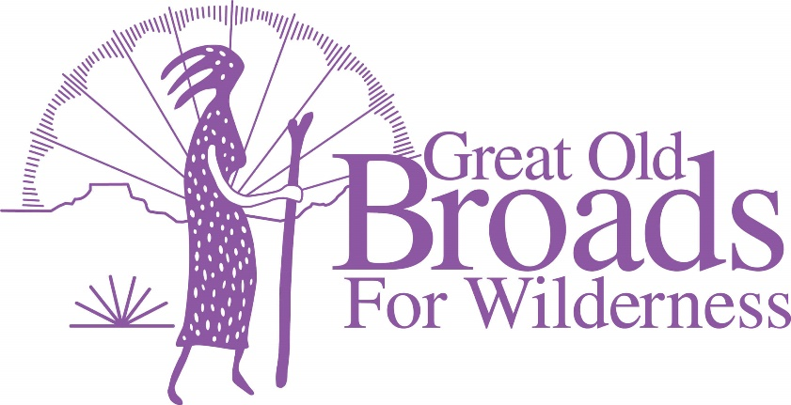
Cascade Volcanoes Chapter Meeting Agenda
May 17, 2022
5:30 – 8:30pm
Community Room Kennedy School McMenamins
5736 NE 33rd Ave. Portland
Eat and Socialize 5:30 – 6:30
Welcome! Happy Spring! Laurie
Presentation: “Monitoring Recreation and Solitude in Salmon Huckleberry Wilderness”, Nathaniel Brodie/Rachel Drake
Wilderness and West-Zone Trails Manager

- ADVOCACY
  - Source to Sea Events
    - Portland July 10 Picnic Kelly Point Park Laurie
    - Astoria Event July 14 Micky
    - Hood River July 4 Micky
    - Rally for Salmon 6/25 10am Willamette Park Laurie

  - Oregon Forest Issues Mt Hood Proposal Micky
  - Oregon Sign on Letter Darlene

  - Pumice Plain Susan

  - Timber sales on Legacy Forests in Private Lands Laurie
Center for Responsible Forestry
  - Clark County Issues Heidi/Laurie

- STEWARDSHIP
  - Recreational Site/Solitude Monitoring Grant Laurie
In person Training June 2, 2022 ZigZag, Or

- MEMBERSHIP
A. Tabling updates Diane
B. Tabling opportunities 6/25 Rally for Salmon Laurie
C. 7/4, 7/10, 7/16 Source to Sea Events

- EDUCATION
  - Equity and Justice Care Call May 19 Linda

- FUNDRAISING
  - Portland Century Ride/Oregon Bike June 19 (Troutdale)
  - Harvest Century Ride Sept 25 Forest Grove Laurie

- FUN
  - Steigerwald NWR Hike May 22 2:30pm with Sally Laurie
  - Campout Moorehead Campground 8/11 – 8/14 Micky
Committee meeting June 20 7pm on zoom
  - July 10 picnic on the Columbia River
Committee meeting May 31 7pm on zoom Laurie
  - 2023 Grand Coulee Broadwalk April 13 – 17, 2023 Micky
Speakers, Stewardship, Food, Fun, Hikes and More!!

Other??????

